

Huawei License Connector ZAIN-KSA

FRS (Functional Requirement Specifications)
Auto-Import connector

License Management

Change History

Version | Change Description | Author | Date
1.0 | First draft | Indrasan Yadav | 04-04-2024
1.1 | Update the existing FRS to differentiate rules to parse licenses details based on node type wise based on node parse in npsbts/npsnodeb/npsenodeb/npsbsc/npsrnc/npsranbs/srancontroller. | Indrasan Yadav | 21-01-2025

Objective
We want to
  - Implement License Management module in NEP for Huawei for ZAIN-KSA.

Positioning/Accessibility
- NEP – Asset & Service Management

Problem statement

Current Problem
At Present NEP does not have feature to manage license details related to 2G/3G/4G RAN network.

Motivation
This is requested as part of POC to be delivered to Zain Kuwait for license management. This feature will be useful to all the customers in future.

5. NEP GUI Requirement

5.1. License Attribute Mapping

The identifier of a license is Node name + License Identifier, same License identifier will be replicated under different nodes.

License will be assigned to nodes based on node name during import XML and CSV.

Attribute | Description | Type | Remarks | Mandator(Y/N)
Node Name | Node Name | String |  | Y
Node Type | Node Type | String | Should be taken from Already Discovered Device Information available in NEP | Y
License Identifier | License Number | String |  | Y
License Detail | License Detailed description of the “License Item” | String |  | N
Allocated | Number of License Allocated | Number | Sometime NULL string is also found which need to display as 0 | N
Usage | Number of License Usage | Number | Sometime NULL string is also found which need to display as 0 | N
Config | Configured License | Number | Available in 4G & 5G License Only (Sometime NULL string is also found which need to display as 0) | N
Unit | License Unit | String | Available in 4G & 5G License Only (Sometime NULL string is also found which need to display as 0) | N
Expiry Date | Expiry Date of License | String | It is available in 2G, 3G, 4G & 5G only, no information available in BSC & RNC License dump.  It will be available in License. EXP: Permanent/NULL/DD:MM: YY. | N
Technology | Include technology Column which will have 2G/3G/4G/5G | String | The value of Attribute “FUNCTIONTYPE=” will decide technology details except BSC & RNC License dump. | Y

Internal & History Tracking attributes
Assigned To | Description | Type | Possible value
Insert Date | Insert record creation date | Date + Time
Modified Date | Information modification date | String

License Management: Main GUI & Reporting

- Objective: Master GUI for License Management
- Trigger: Asset and Service Management License Management
- Linkage to user admin: only UA privileged users has accessed the Main GUI
- Requirement:
  - Have a master Grid listing all the above attributes including the following from Internal & history tracking.
    - Object ID
    - Create Date
    - Modified Date
The grid part serves for reporting thus it shall have followed the standard NEP reporting GUIs as: Template management, import csv, Add from GUI, Edit from GUI, Delete from GUI, Import XML and Export capability with delimiter selection, Quick search/filter bar, sortable & filterable columns, etc.

AI Connector

There are three type of dumps format available in the license files which need to be parsed to extract the details of license information. below sections provides details of fields which need to be extracted and mapped in NEP.
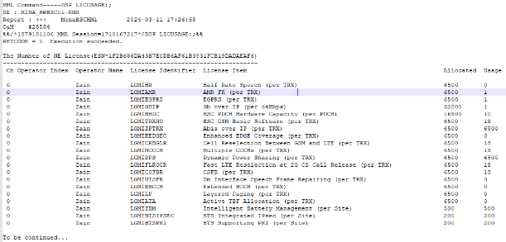
Type-1: BSC & RNC will have the same LIC format.
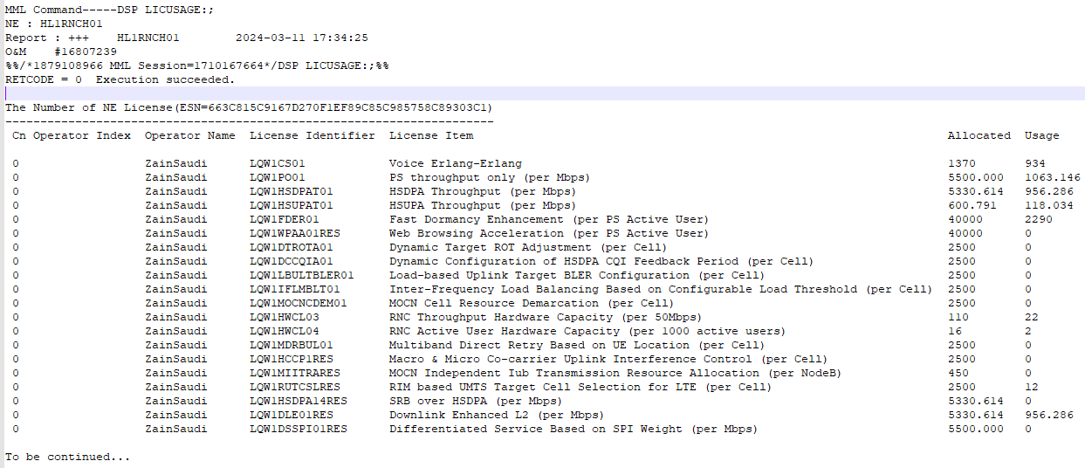

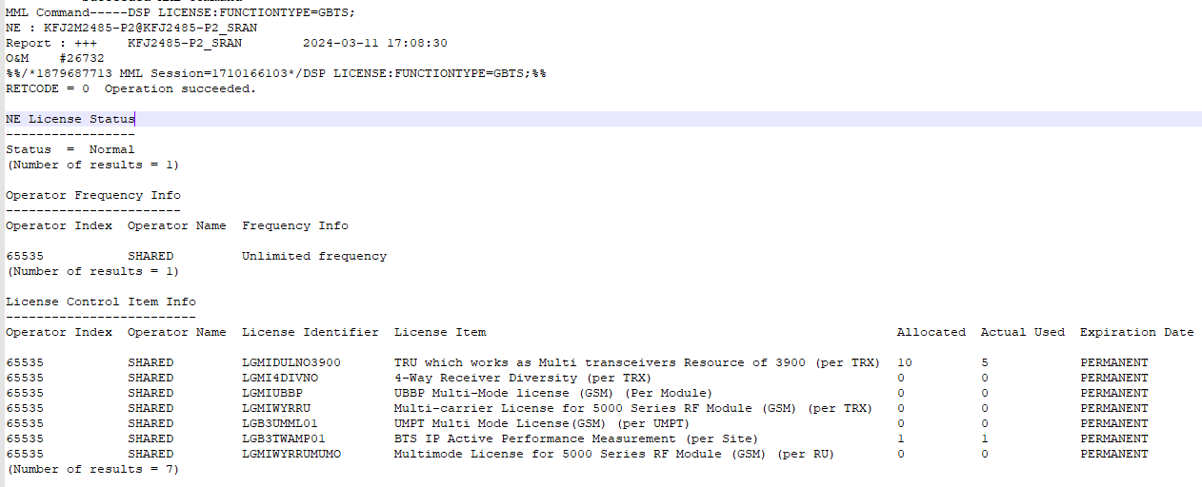
Type-2: 2G & 3G will have the same LIC format.
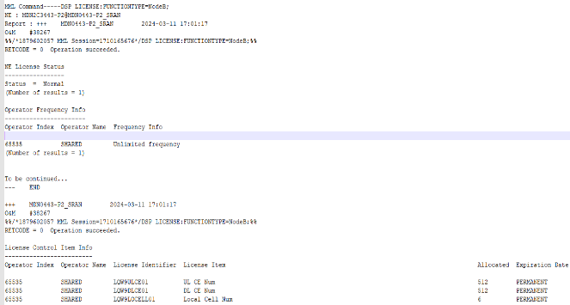
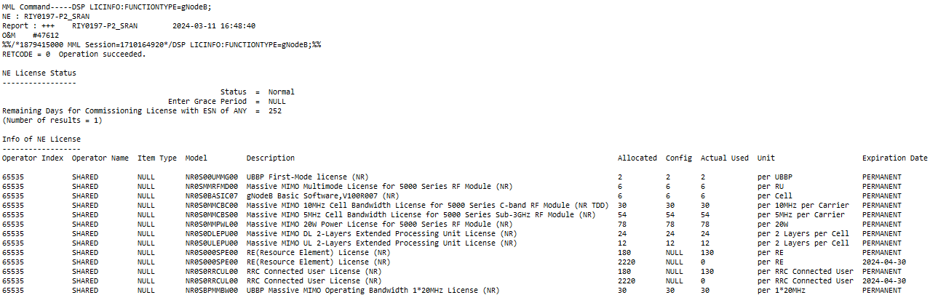
Type-3: 4G & 5G will have the same LIC format.
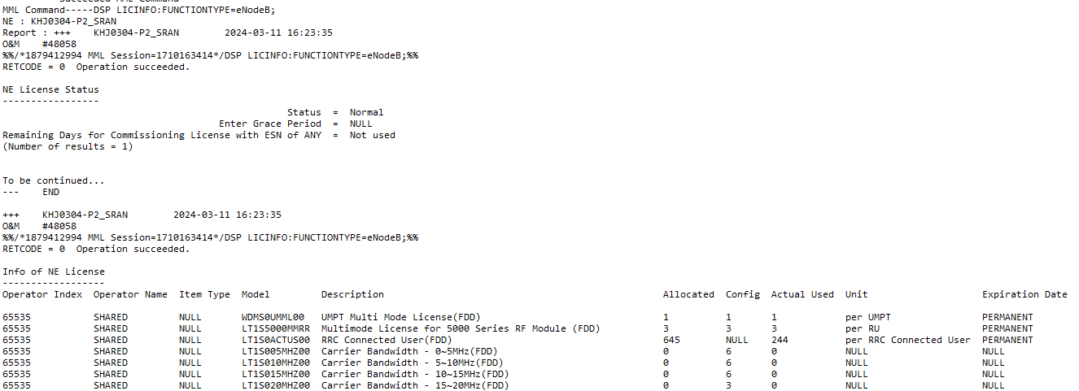

6.1. License File Format for BSC:

A: (Multiple BSC Node License dump will be available in a single license dump whose file name as given below.)
In above SS there are only one dump which has multiple BSC License dump.
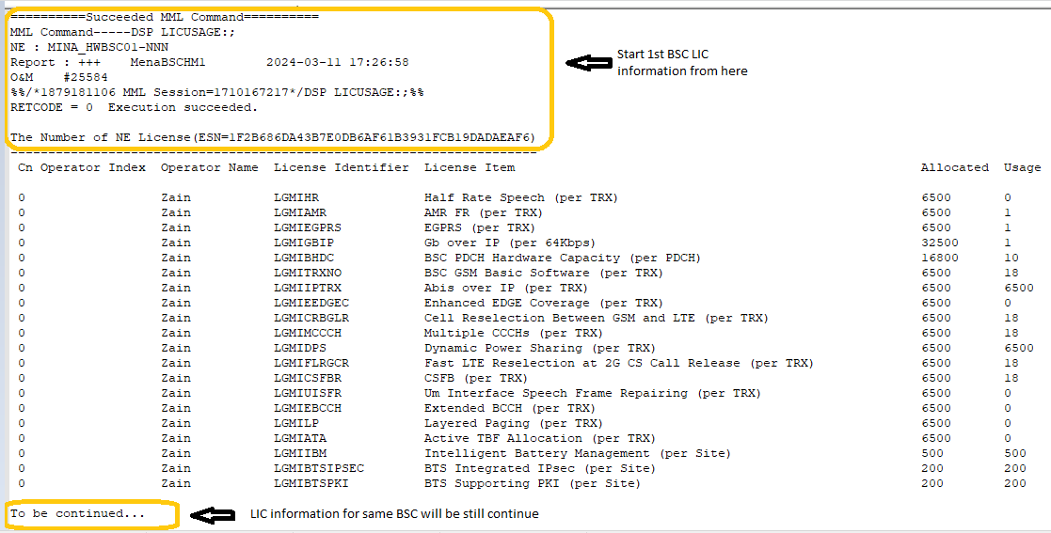
B: 1st BSC license information will be start with ‘MML Command’ & end as given in below & 2nd BSC license information will be start as mentioned here:

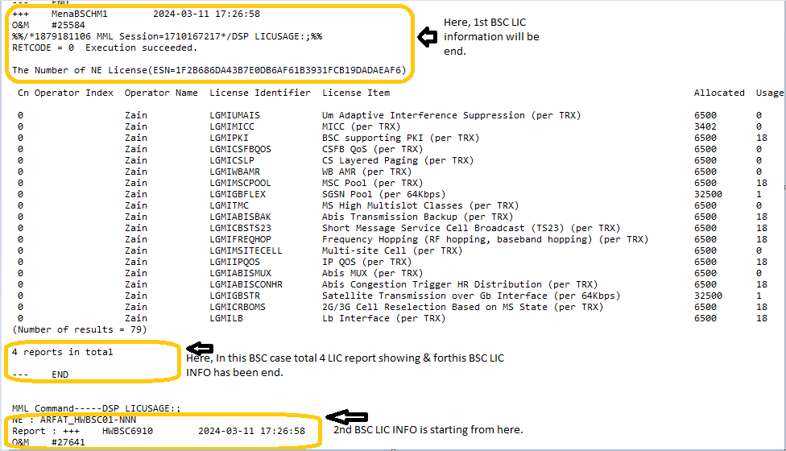
Note: Each & every new node LIC information will be start with “MML Command”

C: Let’s take one BSC dump for example, whose license information will be start as given below:
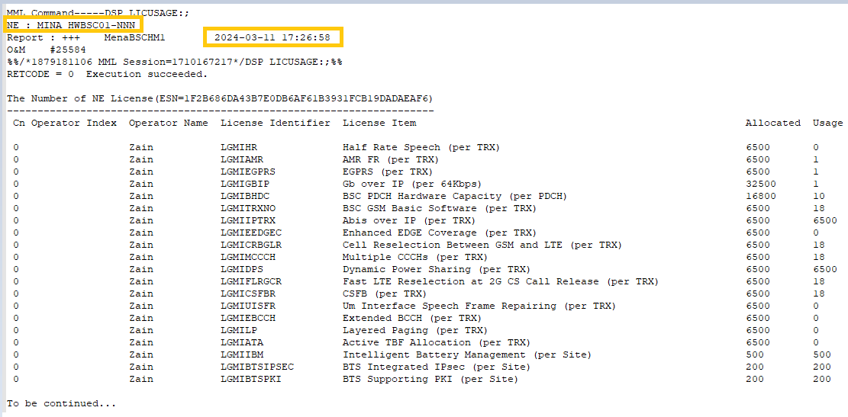

As given in above SS:
MINA_HWBSC01-NNN: Node ID (Node Name)
2024-03-11 17:26:58: Dump collection date

Note: Every Node will come 2 times in full LIC BSC dump in which we will consider that node whose attribute ‘MML command’ has “Type=Current”. EXP: Below SS.

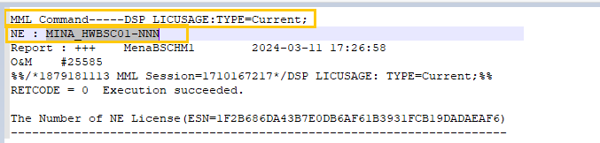

These are details that need to be extracted and mapped in NEP.
- The attribute “NE: “ is equal to Node ID which should be parsed and mapped to every license item.
- Need to parse License Identifier, License details, Allocated, Usage columns from this file and mapped to corresponding attributes in NEP along with Node Name prepended to every license item.
Below table provides mapping of attributes
NodeName_NodeType_DateTime:

NEP Attribute | Dump File Attribute | Mandatory | Remarks
Node Name | NE | Y | This is present in the second line of the dump file.  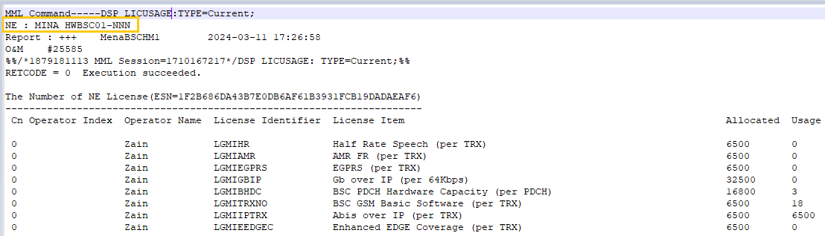  EXP:
Node Type | N/A | N | This is not present in Dump but could be found through dump file name for example: BSC or RNC. Need to discuss on approach.
License Identifier | License Identifier | Y | 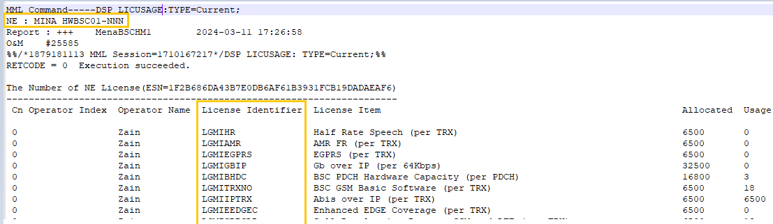  Should be parse as given below:
License Detail | License Item | Y | Should be parse as given below:  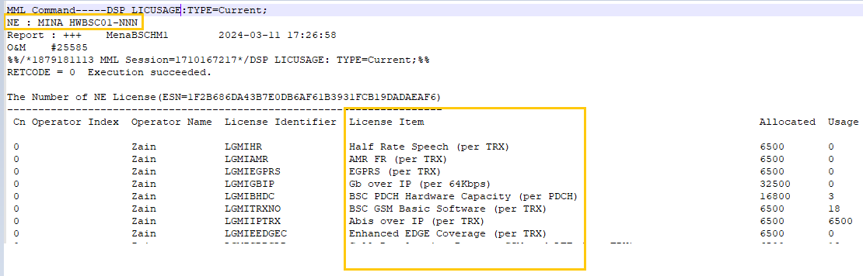
Allocated | Allocated | Y | 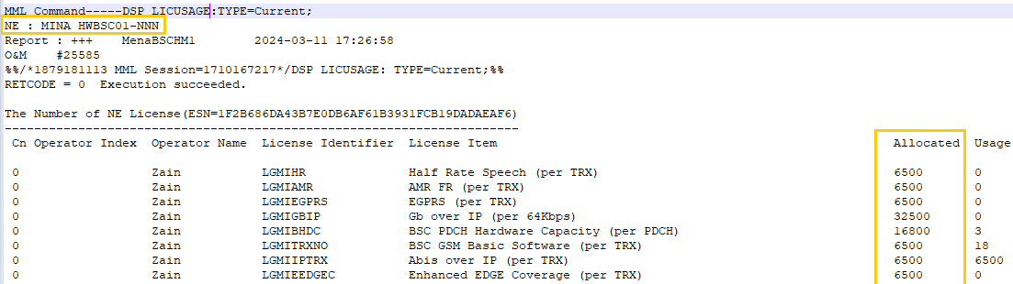  Should be parse as given below:
Usage | Usage | Y | 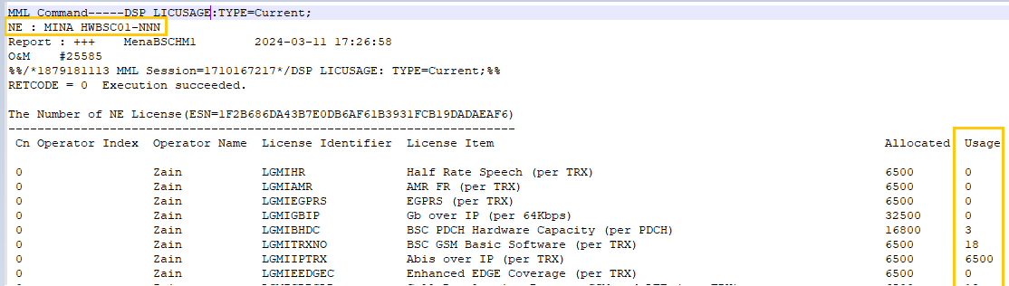  Should be parse as given below:
Config | NA | N | These details are not available in BSC and RNC License information.
Unit | NA | N
Expiry Date | NA | N

License File Format for RNC:

Note: RNC LIC Dump file is same as BSC.
A: (Multiple RNC Node License dump will be available in a single license dump whose file name as given below.)

In above SS there are only one dump which has multiple RNCC License dump.
B: 1st RNC license information will be start with ‘MML Command’ & end as given in below & 2nd RNC license information will be start as mentioned here:
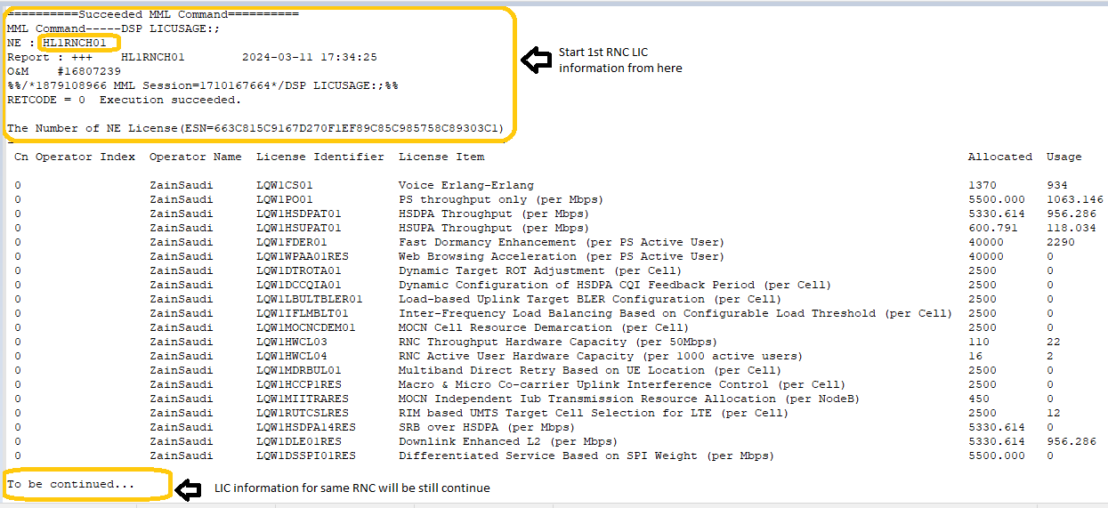
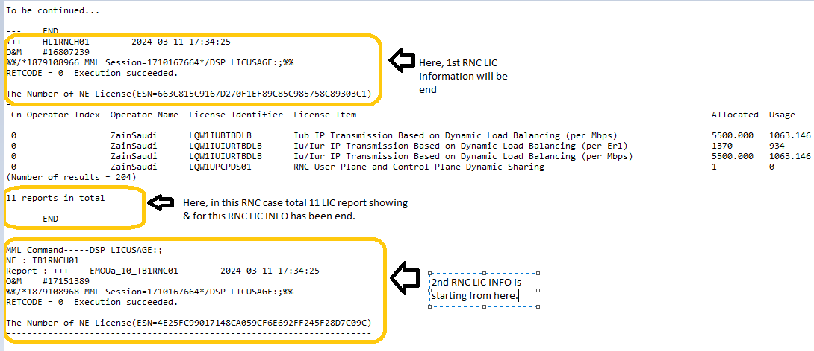

Note: Each & every new node LIC information will be start with “MML Command”

C: Let’s take one RNC dump for example, whose license information will be start as given below:
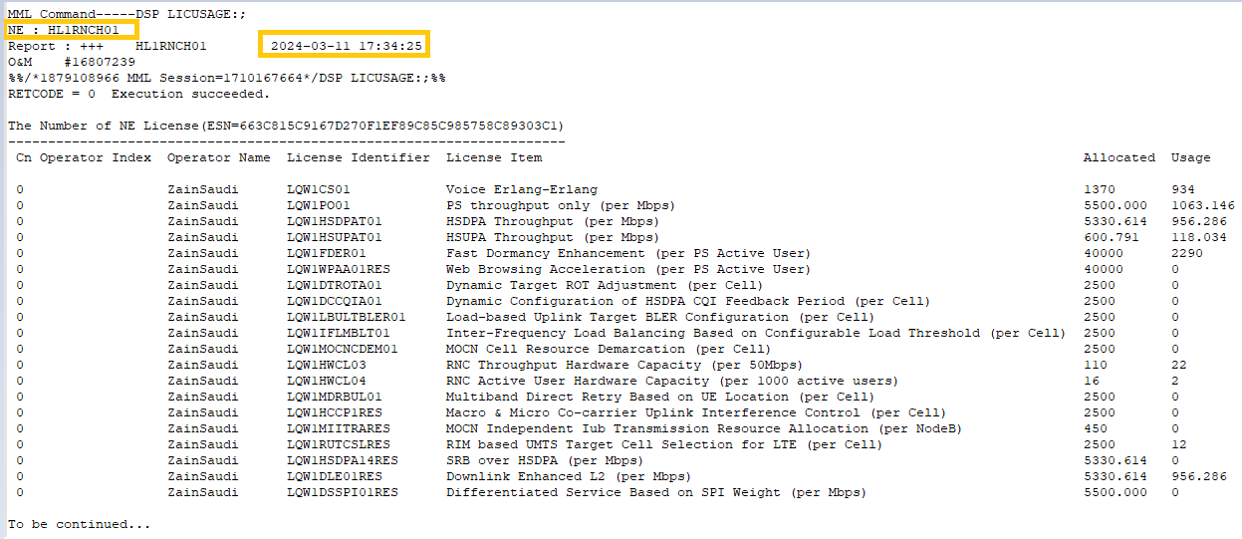

As given in above SS:
HL1RNCH01: Node ID (Node Name)
2024-03-11 17:34:25: Dump collection date
Note: Every Node will come 2 times in full LIC BSC dump in which we will consider that node whose attribute ‘MML command’ has “Type=Current”. EXP:
Below SS.
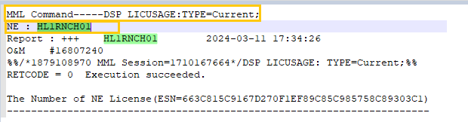

These are details that need to be extracted and mapped in NEP.
- The attribute “NE: “is equal to Node ID which should be parsed and mapped to every license item.
- Need to parse License Identifier, License details, Allocated, Usage columns from this file and mapped to corresponding attributes in NEP along with Node Name prepended to every license item.
Below table provides mapping of attributes

NodeName_NodeType_DateTime:

NEP Attribute | Dump File Attribute | Mandatory | Remarks
Node Name | NE | Y | This is present in the second line of the dump file. Exp:  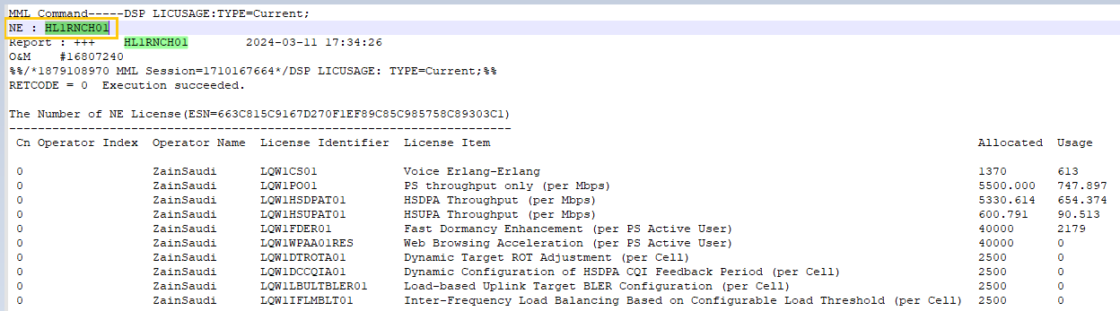
Node Type | N/A | N | This is not present in Dump but could be found through dump file name for example: BSC or RNC. Need to discuss on approach.
License Identifier | License Identifier | Y | 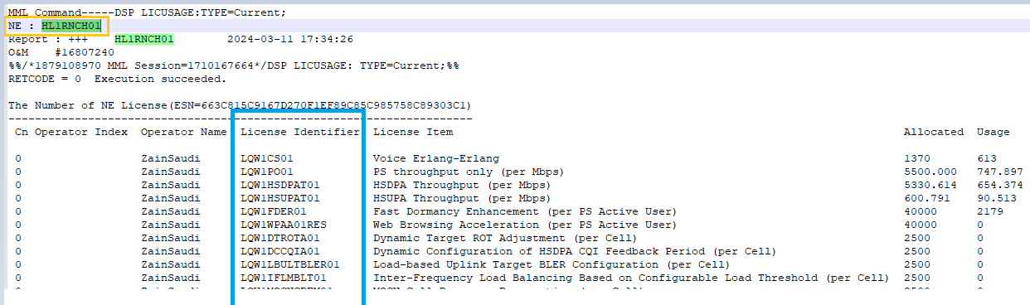  Should be parse as given below:
License Detail | License Item | Y | 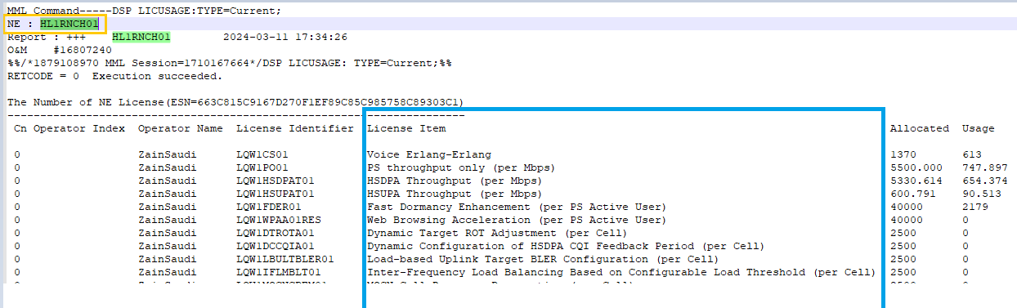  Should be parse as given below:
Allocated | Allocated | Y | 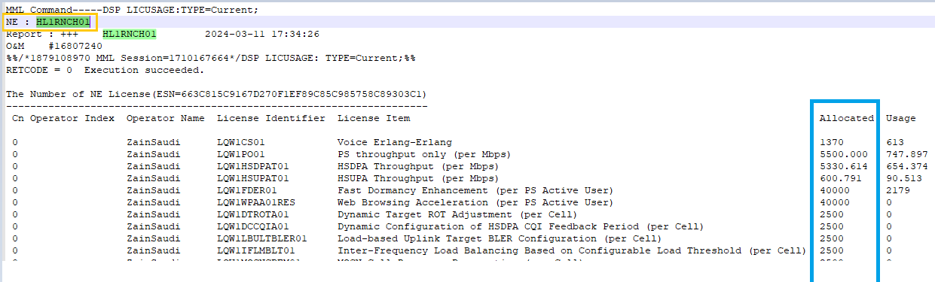  Should be parse as given below:
Usage | Usage | Y | 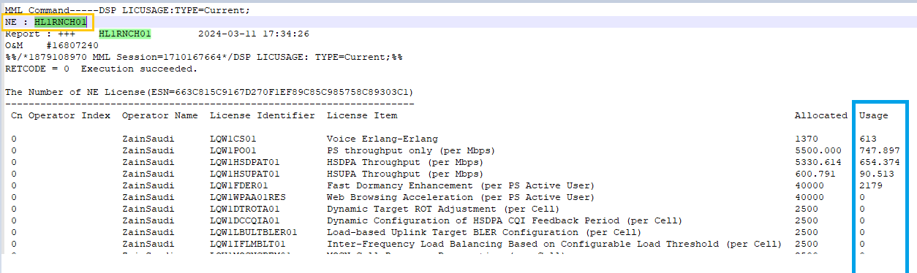  Should be parse as given below:
Config | NA | N | These details are not available in BSC and RNC License information.
Unit | NA | N
Expiry Date | NA | N

6.3. License File Format for gBTS:

To address the scenario where licenses are received based on node type rather than technology type, and parsing occurs in nelicenses based on node ID with technology and node type information, please consider the following approach for processing and validation:
2G/gBTS LIC Dump:
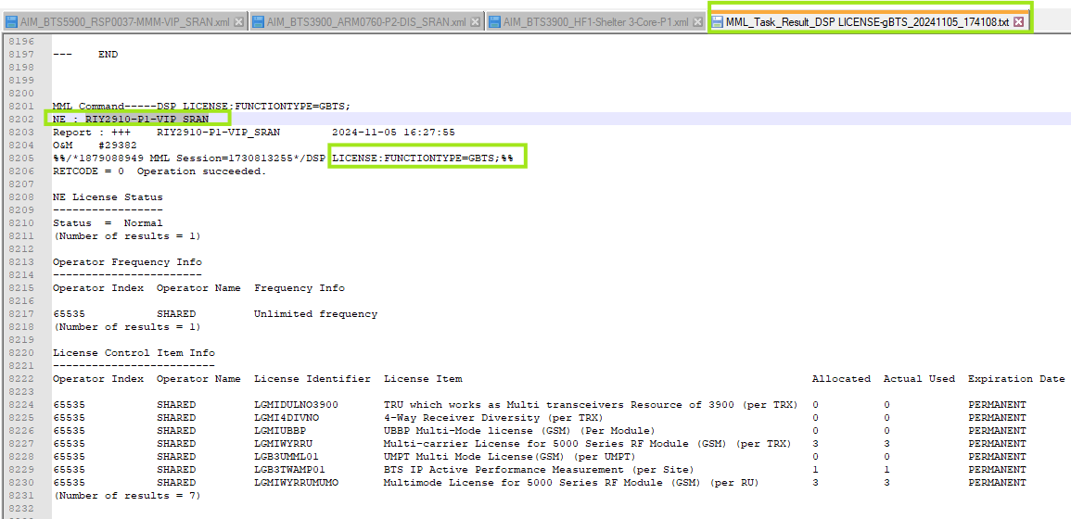
Exp: in above SS the NE: ‘RIY2910-P1-VIP_SRAN’ so here Node ID= “RIY2910-P1-VIP_SRAN”

These are details that need to be extracted and mapped in NEP.
- The attribute “NE: “is equal to Node ID which should be parsed and mapped to every license item. In case where attribute NE will contain‘@’ then Node ID should be parsing the value after ‘@’.
- Need to parse License Identifier, License details, Allocated, Usage, Expiration date, Item Type, Model, Description, Config, Unit columns from this file and mapped to corresponding attributes in NEP along with Node Name prepended to every license item.
Below table provides mapping of attributes
NodeName_NodeType_DateTime:

NEP Attribute | Dump File Attribute | Mandatory | Remarks
Node Name | NE | Y | This is present in the second line of the dump file.  In 2G:  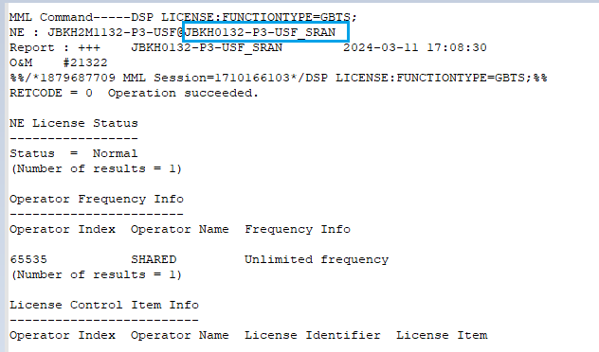
Node Type | N/A | Y | npsbts, npsnodeb, npsenodeb, npsranbs will provide node type based on inventory data.  In LIC also given “FUNCTIONTYPE=” which will represent techonology “Gbts”=2G/”NodeB”=3G/”eNodeB”=4G/”gNodeB”=5G but node type will parse in neicenses.
License Identifier | License Identifier | Y | Should be parse as given below:  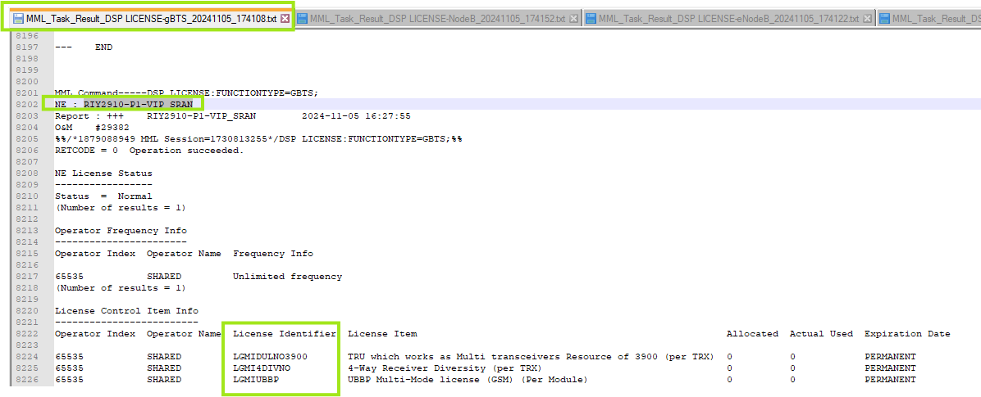
License Detail | License Item | Y | Should be parse as given below:  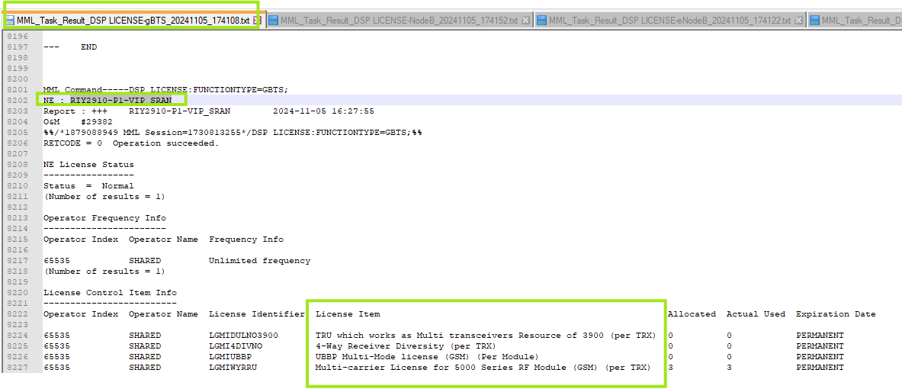
Item Type | NULL | N | This is available in only 4G & 5G LIC dump which is ‘NULL’.
Allocated | Allocated | Y | Should be parse as given below:  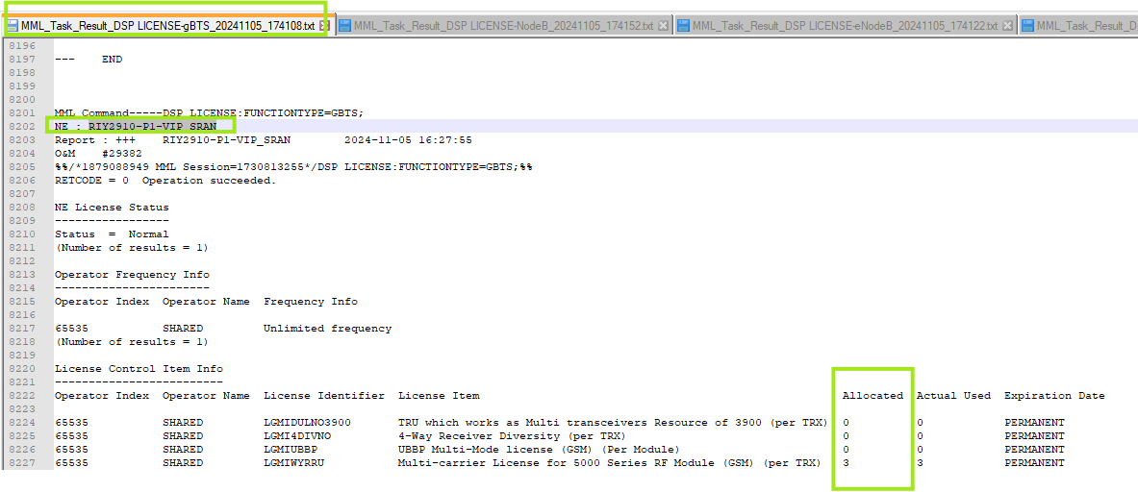
Usage | Usage | Y | Should be parse as given below:  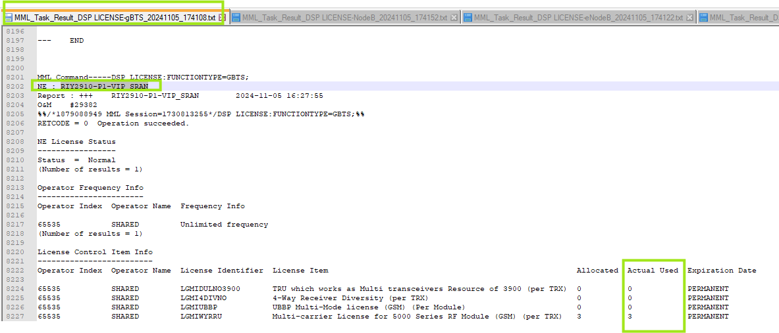
Config | Config | N | In NodeB, there is no information about ‘Config’
Unit | Unit | N | In NodeB, there is no information about ‘Unit’
Expiry Date | Expiration Date | N | It will be parse from attribute “Expiration Date”.  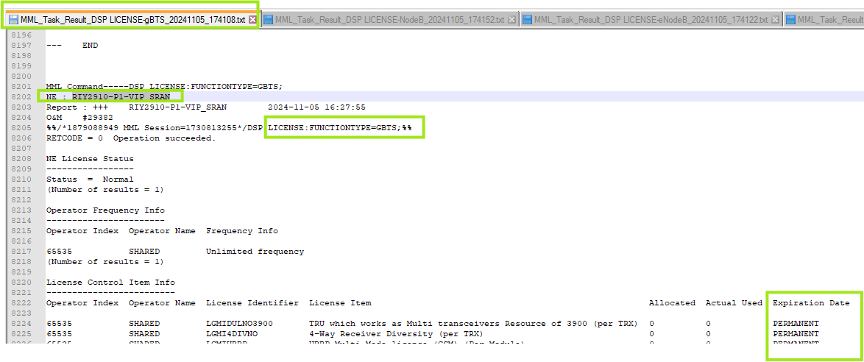

License File Format for NodeB:

3G/NodeB LIC Dump:
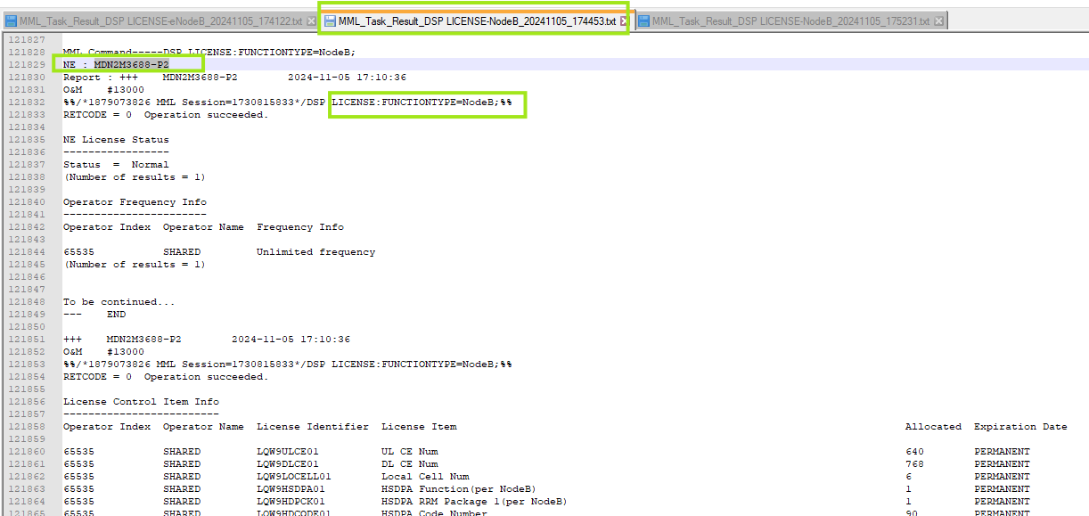
Exp: in above SS the NE: ‘MDN2M3688-P2’ so here Node ID= “MDN2M3688-P2”

Below table provides mapping of attributes
NodeName_NodeType_DateTime:

NEP Attribute | Dump File Attribute | Mandatory | Remarks
Node Name | NE | Y | This is present in the second line of the dump file.  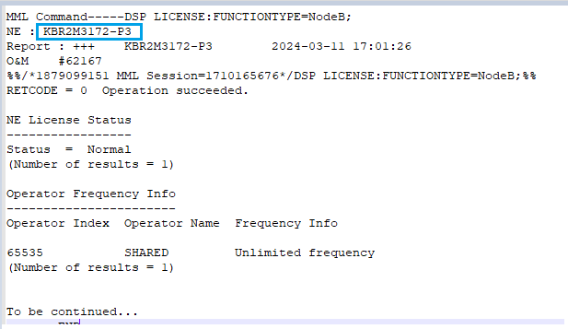
Node Type | N/A | Y | npsbts, npsnodeb, npsenodeb, npsranbs will provide node type based on inventory data.  In LIC also given “FUNCTIONTYPE=” which will represent techonology “Gbts” =2G/”NodeB”=3G/”eNodeB”=4G/”gNodeB”=5G but node type will parse in neicenses.
License Identifier | License Identifier | Y | Should be parse as given below in snippet: it will be considered as “License Identifier” attribute.  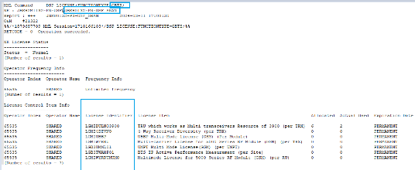
License Detail | License Item | Y | Should be parse as given below in snippet:  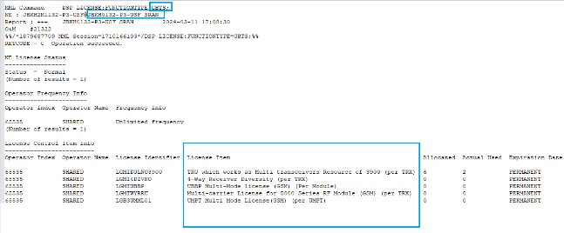
Item Type | NULL | N | This is available in only 4G & 5G LIC dump which is ‘NULL’.
Allocated | Allocated | Y | Should be parse as given below:  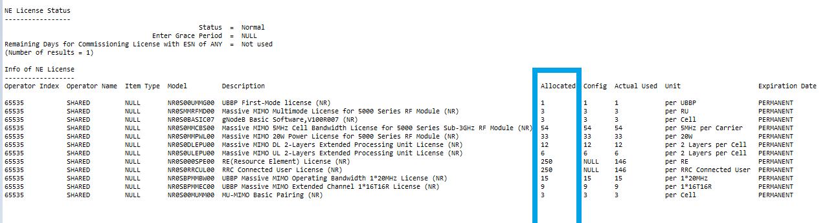
Usage | Usage | N | In NodeB, there is no information about ‘Usage’
Config | Config | N | In NodeB, there is no information about ‘Config’
Unit | Unit | N | In NodeB, there is no information about ‘Unit’
Expiry Date | Expiration Date | Y | Available in 2G, 3G, 4G, 5G dump except BSC & RNC.  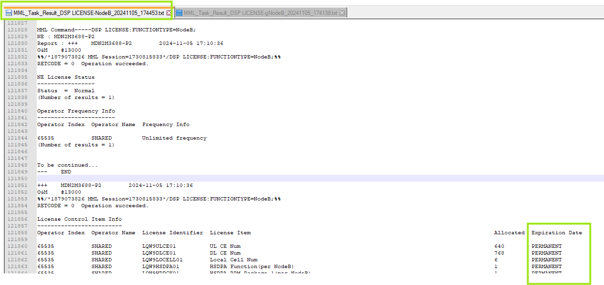  To be parse from attribute “Expiration Date”

License File Format for eNodeB:

4G LIC Dump:
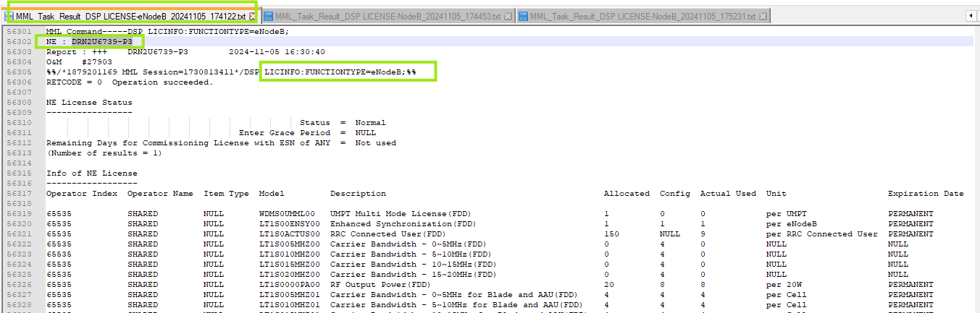
Exp: in above SS the NE: ‘DRN2U6739-P3’ so here Node ID= “DRN2U6739-P3”

Below table provides mapping of attributes
NodeName_NodeType_DateTime:

NEP Attribute | Dump File Attribute | Mandatory | Remarks
Node Name | NE | Y | This is present in the second line of the dump file with “NE”.  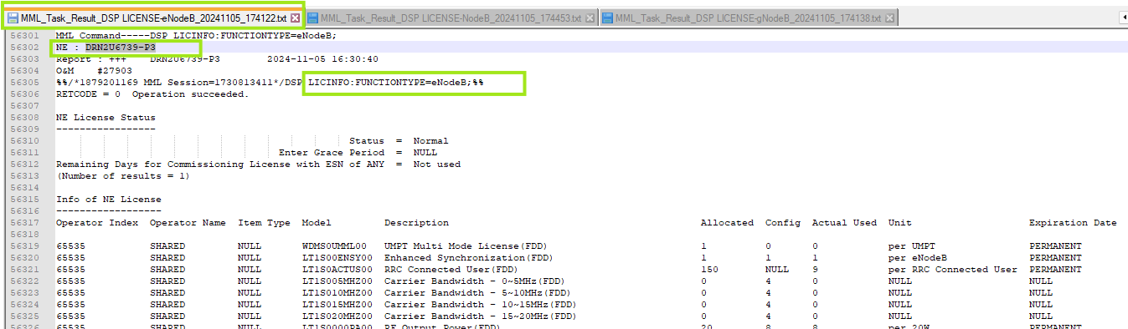
Node Type | N/A | Y | npsbts, npsnodeb, npsenodeb, npsranbs will provide node type based on inventory data.  In LIC also given “FUNCTIONTYPE=” which will represent techonology “Gbts” =2G/”NodeB”=3G/”eNodeB”=4G/”gNodeB”=5G but node type will parse in neicenses.
License Identifier | License Identifier | Y | Should be parse as given below in snippet: it will be considered as “Model” attribute.  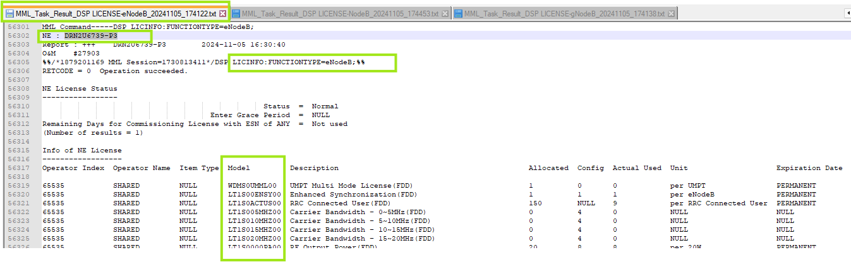
License Detail | License Item | Y | Should be parse as given below in snippet: from attribute “Description”.  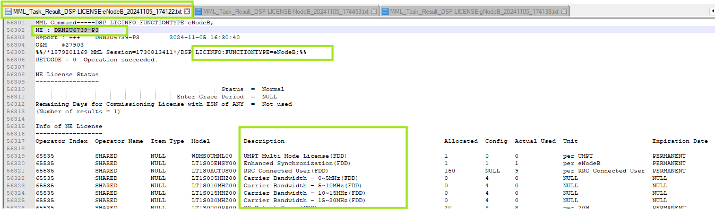
Item Type | NULL | N | This is available in only 4G & 5G LIC dump which is ‘NULL’.  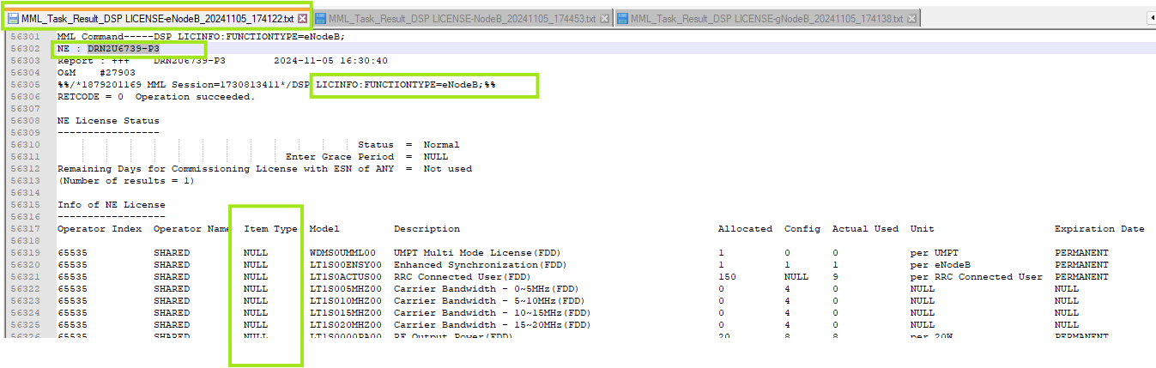
Allocated | Allocated | Y | Should be parse as given below: from attribute “Allocated”  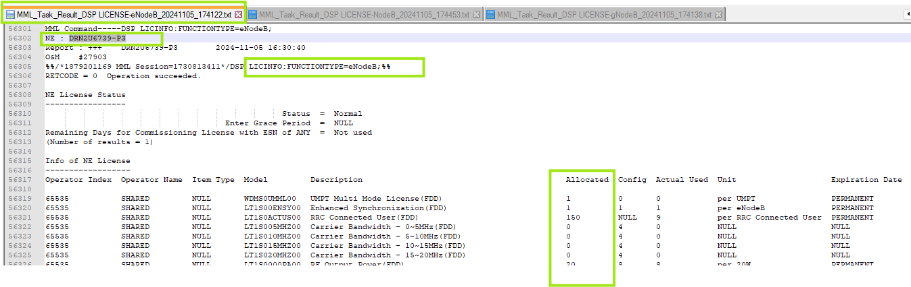
Usage | Usage | N | It is parse from attribute ‘Actual Used’  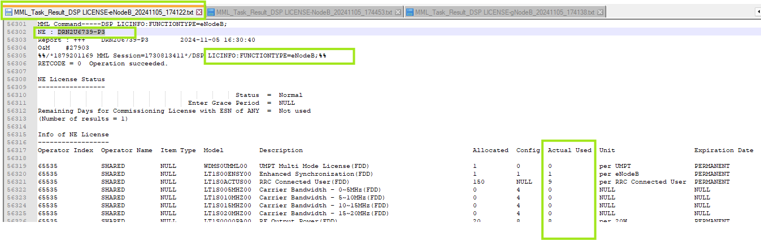
Config | Config | N | It is parse from attribute ‘Config’  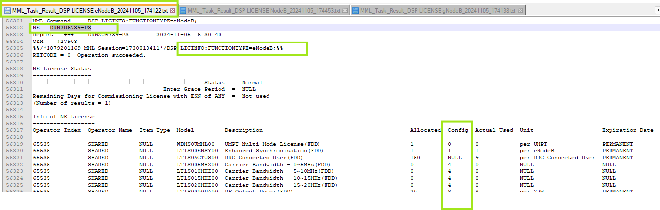
Unit | Unit | N | It is parse from attribute ‘Unit’  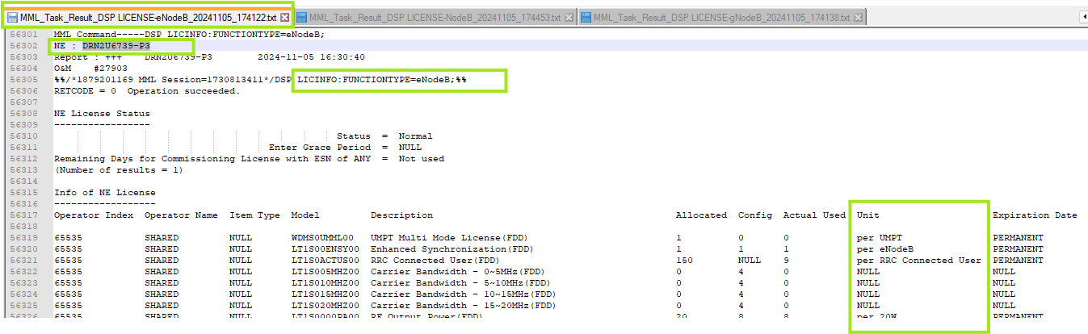
Expiry Date | Expiration Date | Y | Available in 2G, 3G, 4G, 5G dump except BSC & RNC.  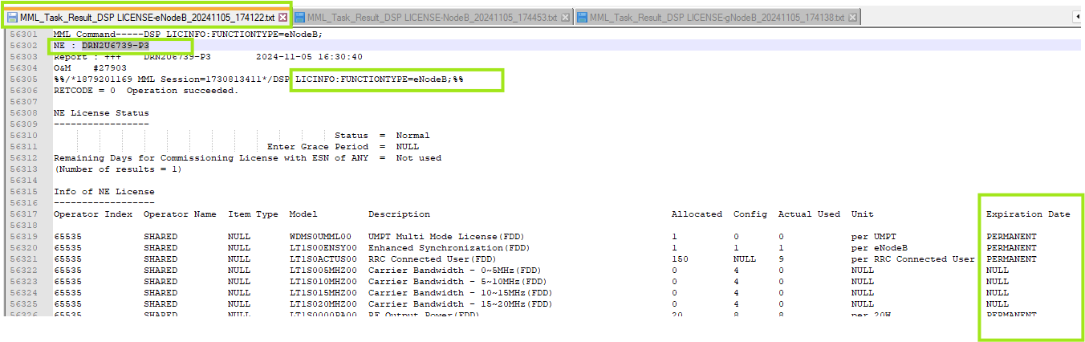  To be parse from attribute “Expiration Date”

License File Format for gNodeB:
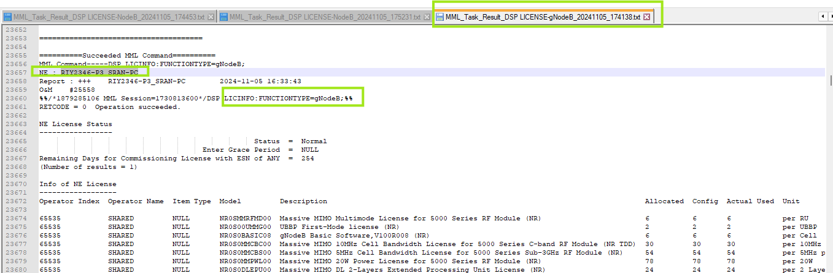
Exp: in above SS the NE: ‘RIY2346-P3_SRAN-PC’ so here Node ID= “RIY2346-P3_SRAN-PC”

Below table provides mapping of attributes
NodeName_NodeType_DateTime:

NEP Attribute | Dump File Attribute | Mandatory | Remarks
Node Name | NE | Y | This is present in the second line of the dump file with “NE”.  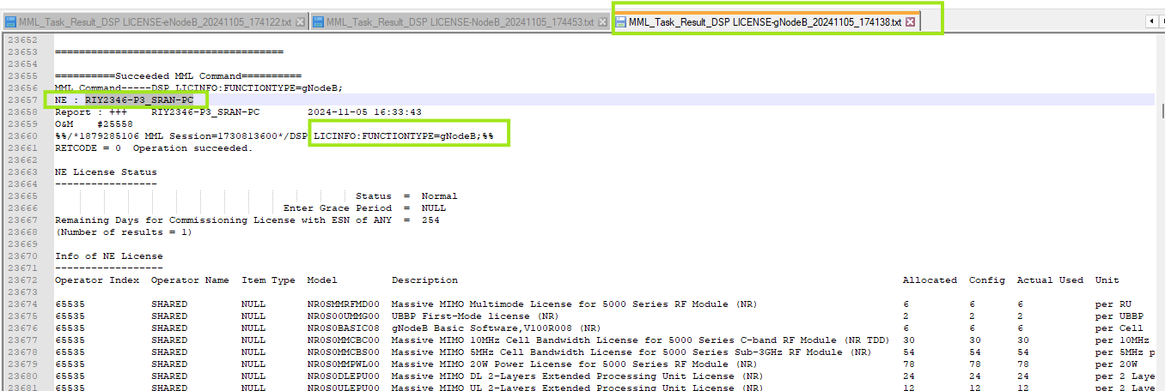
Node Type | N/A | Y | npsbts, npsnodeb, npsenodeb, npsranbs will provide node type based on inventory data.  In LIC also given “FUNCTIONTYPE=” which will represent techonology “Gbts” =2G/”NodeB”=3G/”eNodeB”=4G/”gNodeB”=5G but node type will parse in neicenses.
License Identifier | License Identifier | Y | Should be parse as given below in snippet: it will be considered as “Model” attribute.  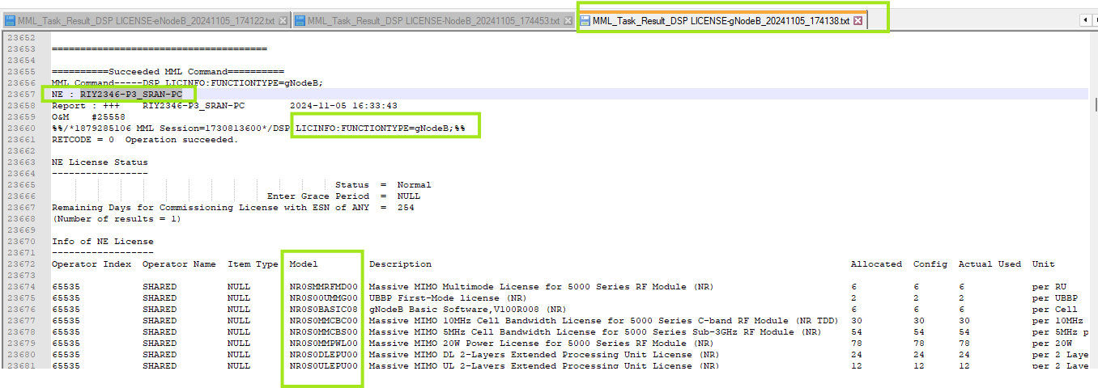
License Detail | License Item | Y | Should be parse as given below in snippet: from attribute “Description”.  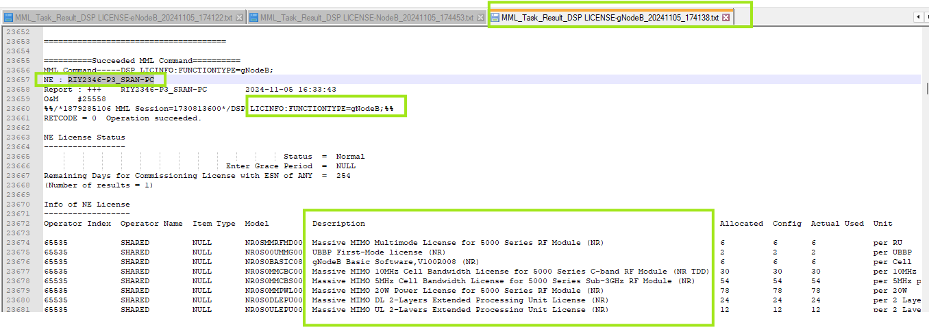
Item Type | NULL | N | This is available in only 4G & 5G LIC dump which is ‘NULL’.  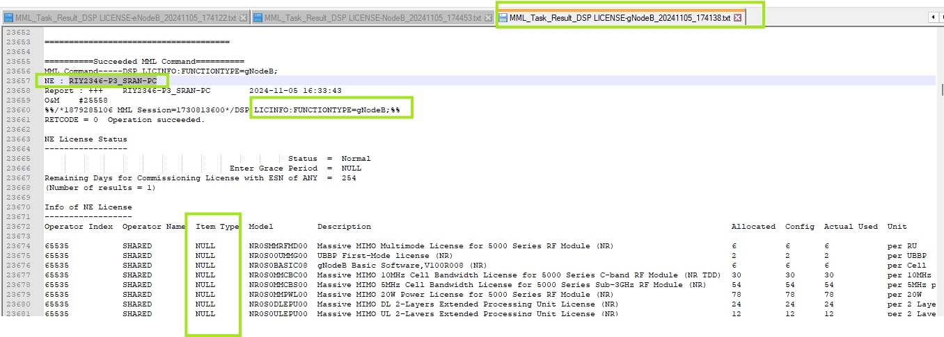
Allocated | Allocated | Y | Should be parse as given below: from attribute “Allocated”  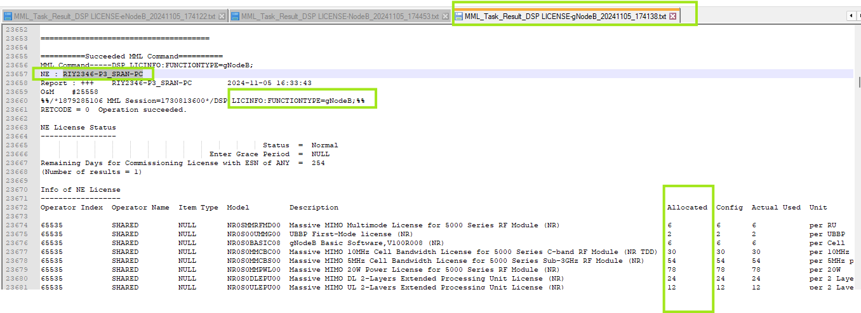
Usage | Usage | Y | It is parse from attribute “Actual Used”.  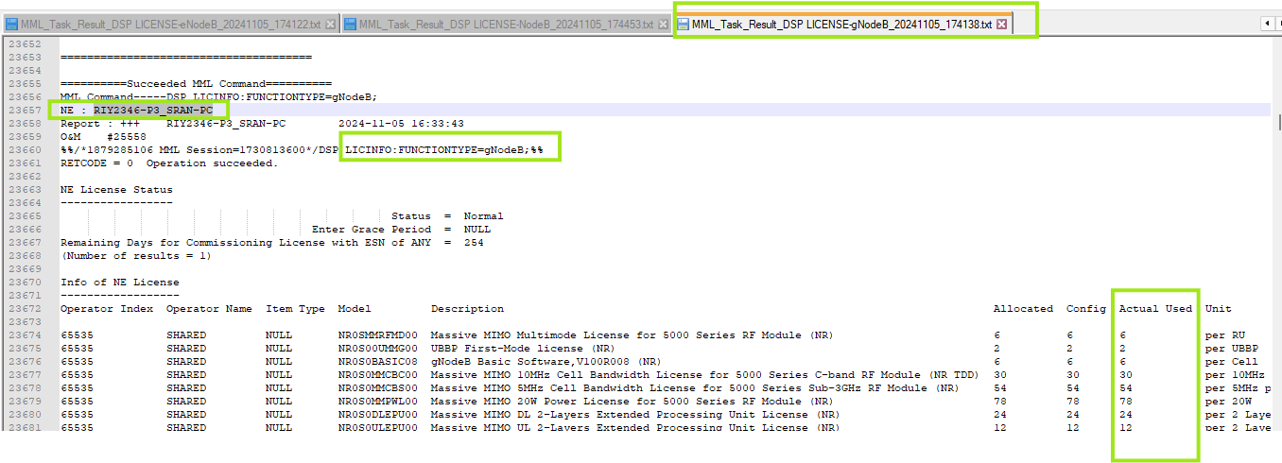
Config | Config | Y | It is parse from attribute “Config”.  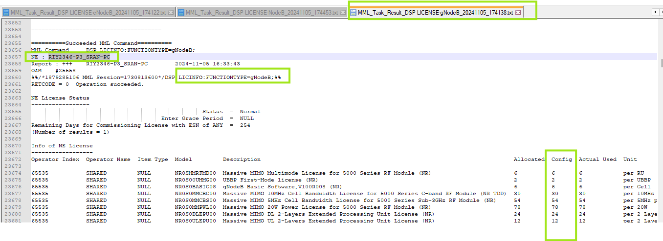
Unit | Unit | Y | It is parse from attribute “Unit”.  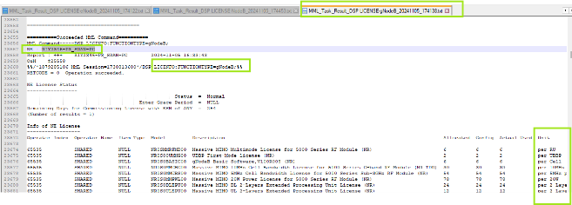
Expiry Date | Expiration Date | Y | It is not available in gNodeB.

6.7 Technology Field Parsing:

Technology should be parsed from the attribute “DSP LICENSE: FUNCTIONTYPE=” in LIC file.
If, DSP LICENSE: FUNCTIONTYPE=GBTS; Then Technology should be set to 2G.
If, DSP LICENSE: FUNCTIONTYPE=NodeB; Then Technology should be set to 3G.
If, DSP LICINFO: FUNCTIONTYPE=eNodeB; Then Technology should be set to 4G.
If, DSP LICINFO: FUNCTIONTYPE=gNodeB; Then Technology should be set to 5G.

For BSC & RNC case there is not any attribute available “DSP LICENSE: FUNCTIONTYPE=” so it should be parse with Node ID name itself.

For Technology understanding in LIC dumps, SS given below for reference:

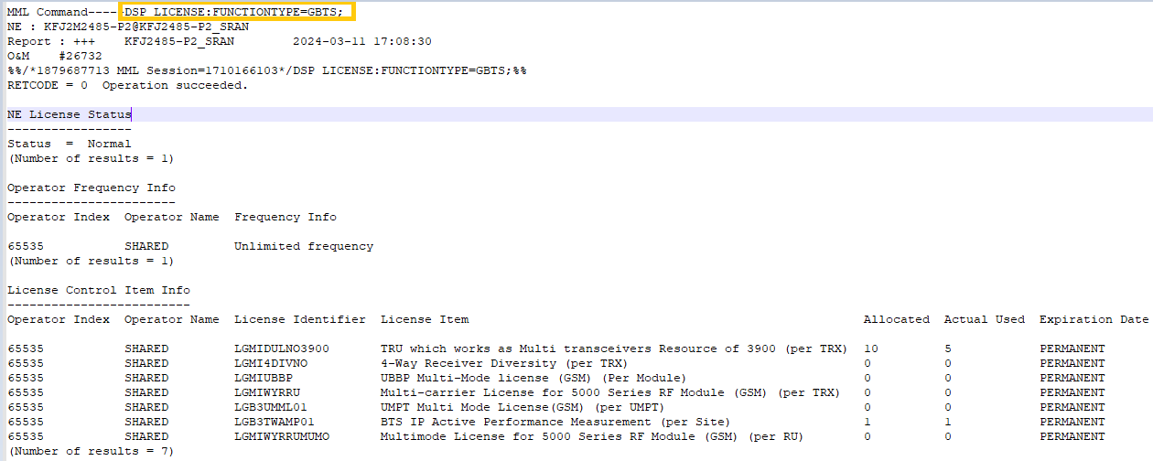
2G LIC:

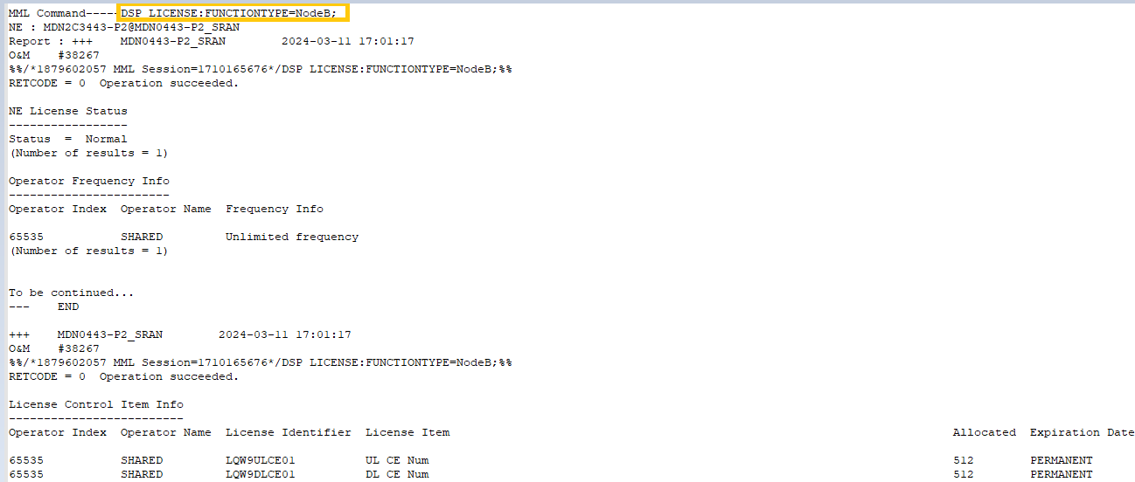
3G LIC:

4G LIC:

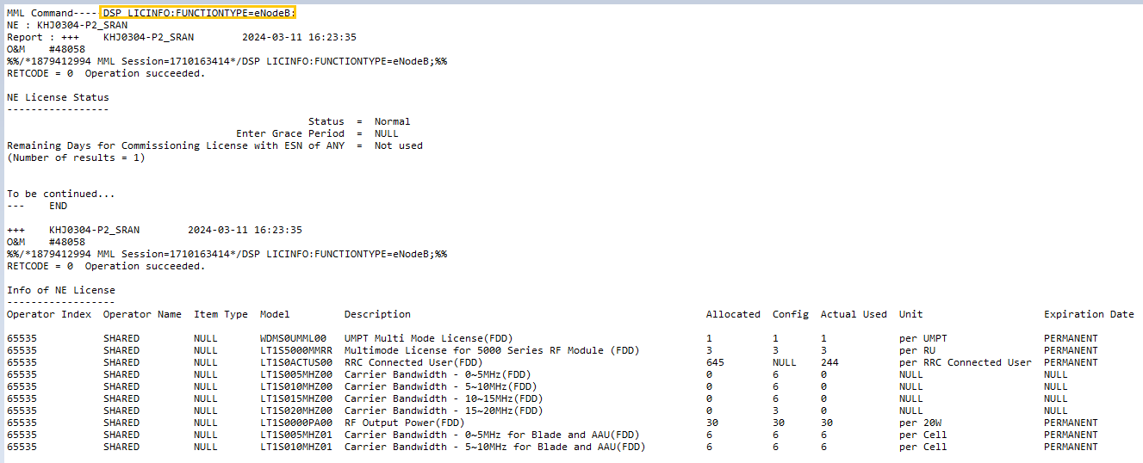
5G LIC:
